Table of Contents

Introduction………………….2

Design & Analysis ……………2

Details About Website……3

Home……………………………………..3

About…………………………………….3  
CV………………………………………….3

Social……………………………………..4

Contact…………………………………..4

Model……………………………………..4

**Wireframe……………………………….4**

Home page………………………………5

About page………………………………6

CV page…………………………………….7

Social page………………………………..8

Contact……………………………………..9

**Mockups………………………………..10**

Home page………………………………10

About page………………………………11

CV page…………………………………….12

Social page………………………………..12

Contact……………………………………..13

Nav bar……………………………………..13

Footer………………………………………13

About nav bar and footer…………13

Social links………………………………..14

**Validation………………………………..14**

**Conclusion……………………………….14**

**Referencing…………………………………...15**

**Introduction**

This assignment is based upon HTML5 (Hyper Text Markup Language) HTML5 and CSS3 (Cascading Style Sheets). HTML5 is the contemporary evolution of the same old that defines HTML. The time period represents one of a kind principles. It is a new version of the language HTML, with new factors, attributes, and behaviors, and a larger set of technologies that permits the constructing of extra various and powerful Web sites and programs. This set is now and again referred to as HTML5 & friends and regularly shortened to simply HTML5 and CSS3 is the maximum current development of the Falling Templates dialect and goes for increasing CSS2 and CSS1. It brings a considerable measure of hotly expected oddities, as adjusted corners, shadows, slopes, advances or moves, and in addition new formats like multi-segments, adaptable box or lattice designs.

The web site was made of an individual resume and Curriculum Vitae. The selection to layout a site on CV and character functions of intrigue. CV portrays approximately the portfolio which offers us singular detail. It makes new photo in web site to reveal up approximately the character element on the way to assist build new portfolio. The examination divide exceptionally essential as there's a piece of various desires.

As a difficulty of first importance, the wireframe of the site turned into made to plot the structure of the site. The site become introduced the use of HTML and styled and excited by using CSS. The web page consists of 6 website online pages i.e. Home, About, CV, Social, Model and Contact. All pages contain awesome substance of person detail. These pages are interlinked with each other. After the finishing of web engineering it is trailed by way of change and examination wherein a quick delineation of the website and the vernacular used to collect it become cleared up. The examination isolate carries six locations which became taken as a kind of viewpoint that inspired character to element.

**Design & Analysis**

The undertaking was given to us in week 12. Starting there ahead, our module teacher started to improvise us in dealing with the issues that develops in the midst of the undertaking. The undertaking was to plot a site of individual resume and CV. Everything now can be found in web. People can without a doubt find our own detail without leaving their comfort which is at home. They would now have the capacity to find my own particular detail that they require with just two or three ventures by scrutinizing them on the web. These destinations have made it more profitable and effective.

For this we used HTML (Hypertext Markup Language) that's a standard markup vernacular for making website pages. These are building squares of HTML5 web page which might be addressed through marks. HTML uses these names to render the substance of the page. We used CSS3 to light up and style the website online pages, we used CSS3.

In precise, to diagram a website we want to make a wireframe. It is a display screen format that displays the skeletal shape (framework) and substance of the website. It indicates the structure of the pages without any outlines inclusive of what pages to interface in which.

**Details about websites**

**Home**

Touchdown page the main wireframe is the website. It contains name and some content material within the other phase. This is trailed by direction bar that incorporates Home, About, CV, Social, Model and Contact in nav bar. An image is placed in between and in the body part some contents are displayed. Finally, the footer part consists of 'Copyright © - Shahas Dhungana’.

**About**

This page is the second page of the Curriculum vitae website. It consists a short lifestyles story and professional developer. Also this page followed by the nav bars Home, About, CV, Social, Model and Contact. To sum up this page the footer contains of 'Copyright © - Shahas Dhungana’.

**CV**

This page is the third page of the website which consists of three boxes which is made from flex property of CSS3 (Cascading Style Sheets) in which first box consists of qualifications table in which all the qualification are completed till now are included, following through the second table a chart of completed programming language are displayed and at the third table some of the achievements are shown and also this page followed by the nav bars Home, About, CV, Social, Model and Contact. To sum up this page the footer contains of 'Copyright © - Shahas Dhungana’.

**Social**

This is the fourth page of the resume website, it consists of social links Facebook, Instagram, GitHub, Twitter, LinkedIn, Reddit, Pinterest and Googeplus, when one of the link is clicked social link of that particular linked is opened. Likewise this page took after the nav bars Home, About, CV, Social, Model and Contact. To sum up this page the footer contains of 'Copyright © - Shahas Dhungana’.

**Contact**

This is the fifth page of Curriculum vitae website. This page consists of a form which includes Username, email, subject, message and submit button by using HTML5 (Hypertext Markup Language) also a guide of my area on earth utilizing Google maps including location these all are including address, zip code , along with the nav bars Home, About, CV, Social, Model and Contact. To sum up this page the footer contains of 'Copyright © - Shahas Dhungana’.

**Model**

This is last or sixth page of the website. This page is report of the Curriculum vitae website, this page is provided by links, mockups and screenshots. Also it include the sketches or the wireframes, proof of having authorized utilizing W3 schools validator.

**Wireframe**

It is the start of web site improvement. It is the diagrammatical portrayal of website online that proposes about interface and connection among website pages. It depicts the substance and additives of web page. It is completed before outlining the web page. It is a lot similar to outline that aide’s earlier development of it. Here, it carries every component and segments of the website online which is required to signify like emblem, course bar, header, footer, frame and a few greater. It help us in additionally making plans of website online as we can encompass the required matters and evacuate the superfluous ones so as to upgrade it better. This is the honest diagram talking to the design of the web page alongside the website pages. It may be made by means of utilizing various devices like Word, Artist, Visio, paint and others.

In my case, I have created wireframe with the help of framebox.org that helped to successfully developing the wireframes. The wire frames websites are listed below:

1. **Home page** :

In this wire frame there is very short description and there are five buttons which contains header, navigation bar

, image, body and footer part.

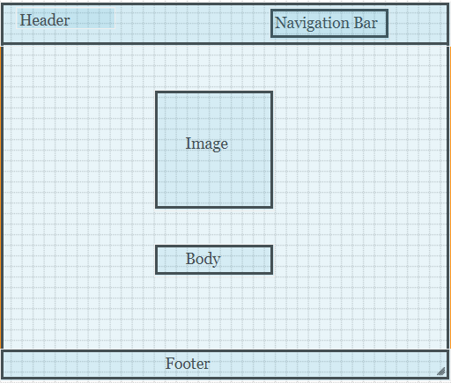

1. **About page:**

In this wire frame there is short information about me there are six buttons which contains header, navigation bar

, image, body details, body and footer part.

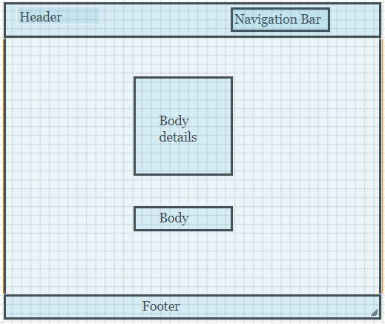

1. **CV page:**

In this wire frame there is some info about resume where there are three boxes and also there are six buttons which contains header, navigation bar

, image, three boxes and footer part.

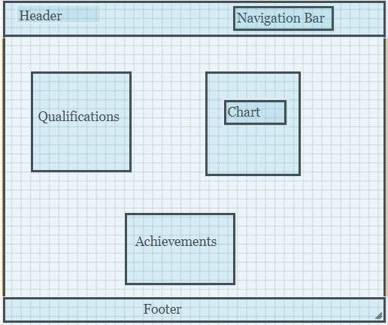

1. **Social page:**

In this wire frame there are eleven buttons in which eight buttons are links of social links and other contains header, navigation bar and footer part.

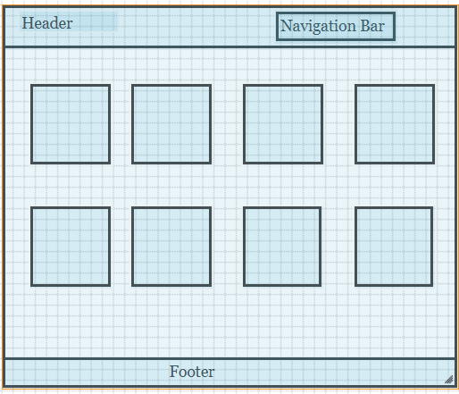

1. **Contact page:**

In this wire frame there are 4 buttons in which there are one is submit bottom of form and other shows the contact details contains header, navigation bar and footer part.

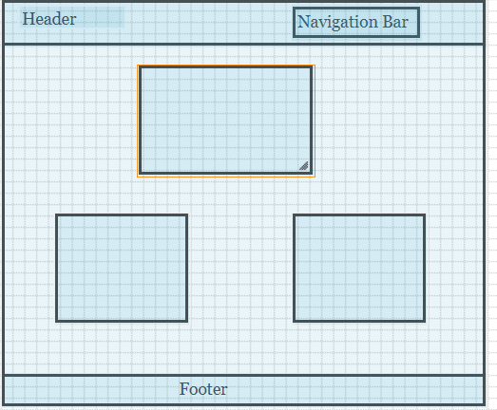

**Mockups:**

While we start the manner towards outlining (or re-planning) the website, the primary step is to make an affiliation of website on-line mockups to position out the appearance and experience of my internet site. These mockups are basically pics we make that display the particular internet site online will look like with no watching for to jump immediately into coding. Those mockups are without a doubt degree images that cannot be related to, but look like a display capture of a site internet website. We utilize those mockups as an approach to impart plan thoughts in advance and backward with our customers and furthermore as an "define" to build up the web page once configuration is completed. To explain the furthermore about the mockups I have listed some mockups of my website which are given as under:

1. **Homepage**

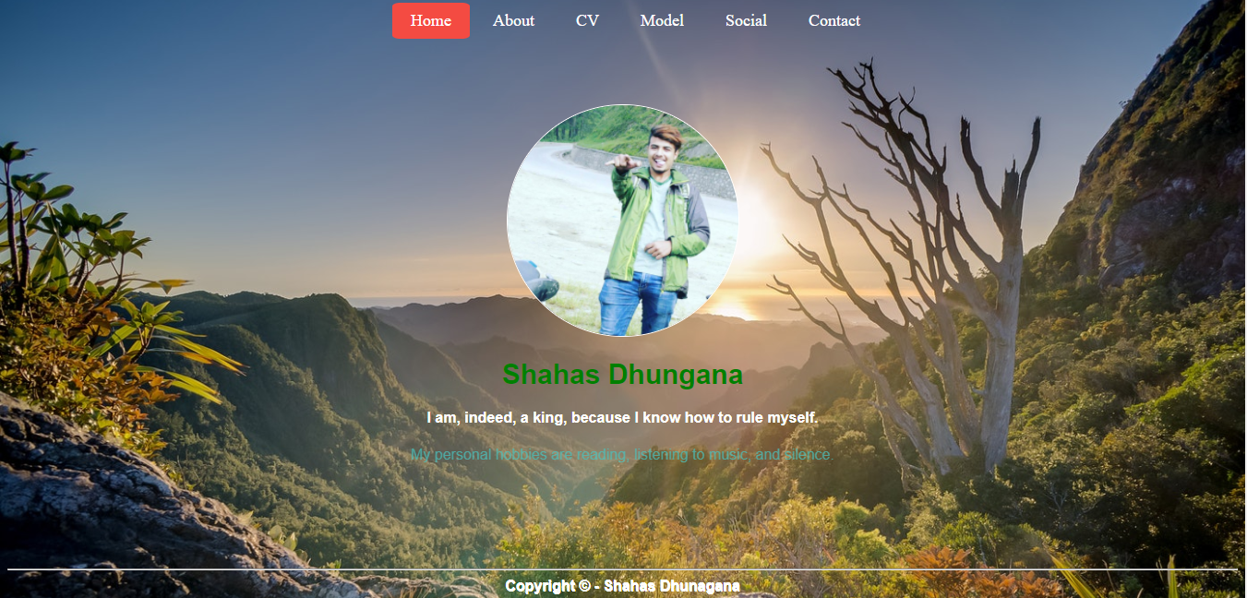

1. **About**

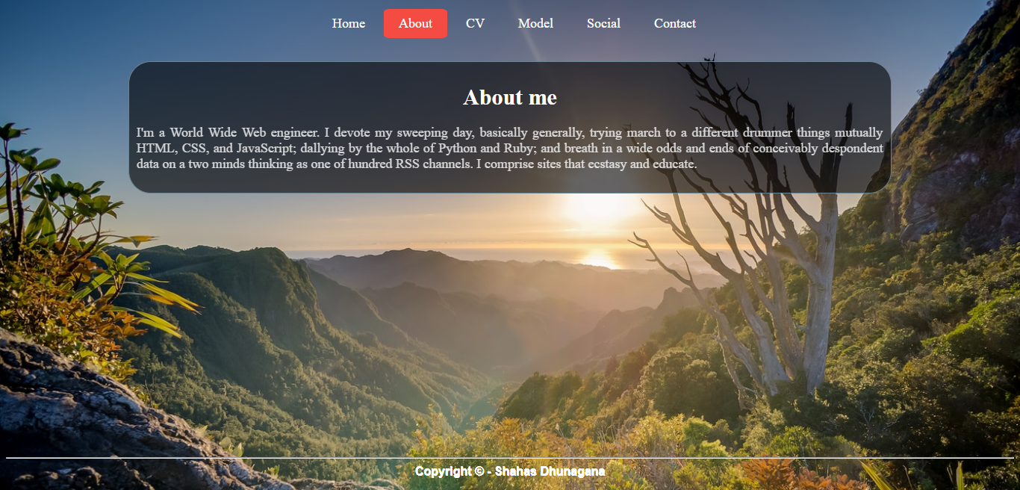

1. **CV**

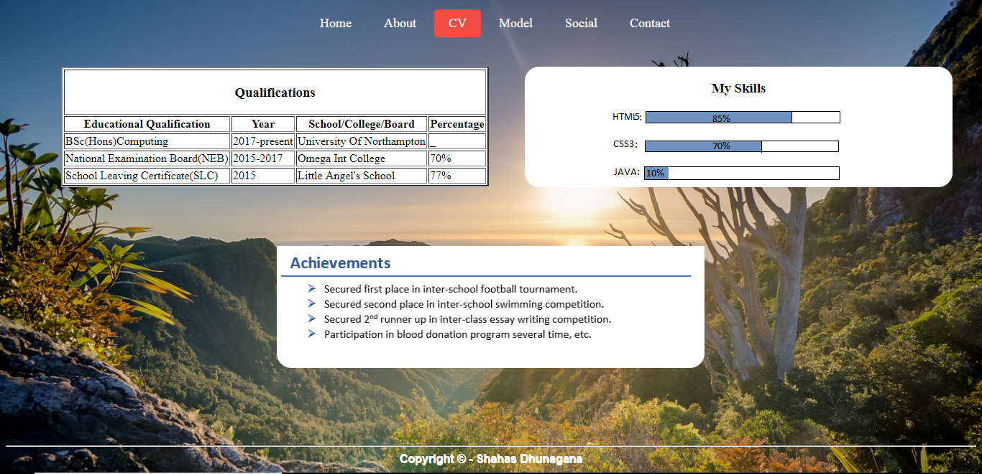

1. **Social**

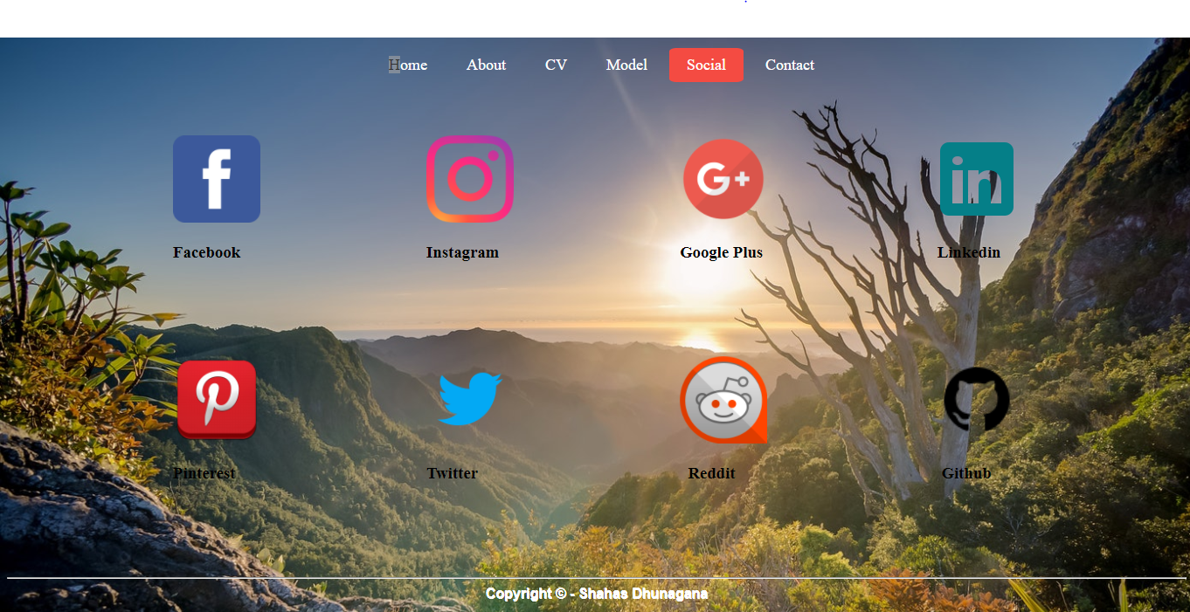

1. **Contact**

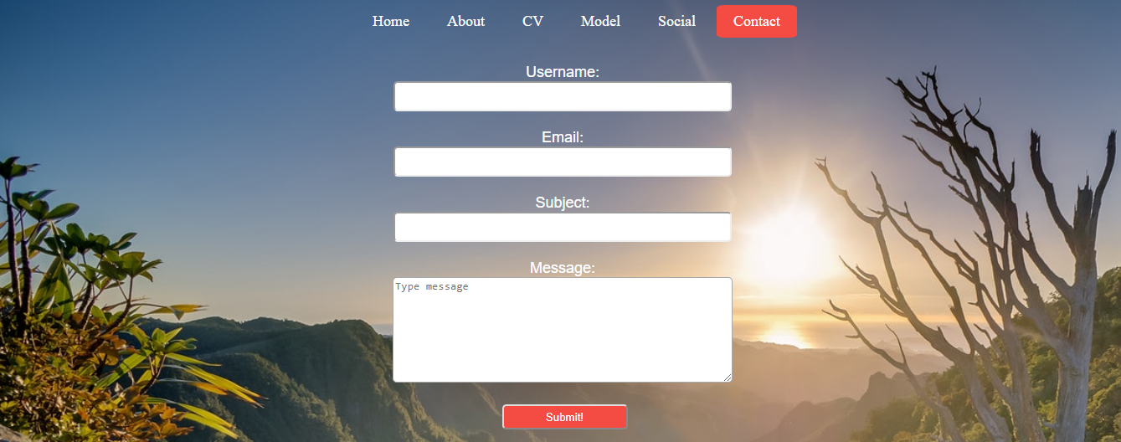

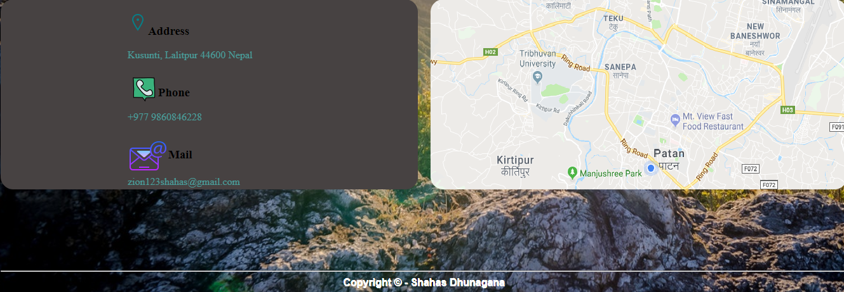

1. **Nav bar**



1. **Footer**



**About Nav bar and Footer**

With the help of CSS (Cascading Style Sheets) it is easy to decorate the nav bars. In the given nav bar there are six buttons in which all buttons have different webpages through nav bars it is easy to go from one page to another or vice versa. Footer is also an important element of the web page, as it makes the webpage interactive and eye catching. Also with the help of CCS footer can be decorated in many ways. In the given scenario of footer the footer contains 'Copyright © - Shahas Dhungana’. To sum up, Nav bar and footer helps to make interactive and quality website.

1. **Social links**

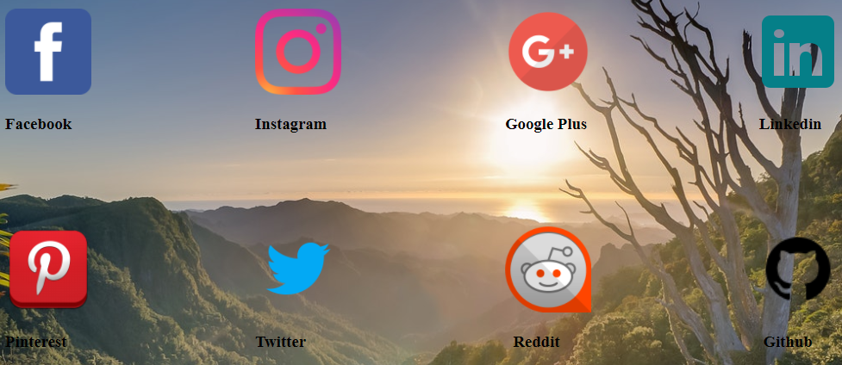

**Validation**

To check the validation of my website, I used W3C validation service for my validation and applying this there is no error code in HTML (Hypertext Markup Language) and CSS (Cascading Style Sheets).

**Conclusion**

The precept locations of this coursework is to create and recognize the concept of site development. This development is not just for evaluation purpose yet it without a doubt for the development of self-mastering nation of thoughts and scholarly development. Since, this complete venture was tied in with constructing up a site for the employer in view of market esteem and customers request. Since, creating web page become now not all that easy stuff. Our module pioneer guided us in creating web page via giving important substance. This helped us in actualizing our hypothetical records for all intents and functions, all matters taken into consideration. This complete paintings had been completed by using self– learning guided via module pioneer. Here we discovered out about HTML (Hypertext Markup Language) which turned into utilized as a part of composing the shape of website. This is the key which empowers programs to peruse our html document. CSS (Cascading Style Sheets) template was applied as a part of styling each any such substance of web page. We observed out about the tenets, labels and parameters applied as a part of styling those substance of web site. There is no use of JavaScript as it may be difficult to make use of it in website pages. All the coding became accomplished in that made coding procedure drastically less worrying as there has been highlights that strengthened HTML5 and CSS3. Likewise, web site become produced inside the wake of assessing special sites also by reviewing there components and substance of pages. It made us fearless and unfastened from others. It builds up a mentality of positive understudy. Best piece of this appraisal, is that it creates possibility in understudies through upgrading their getting to know aptitudes and testing information of understudies. It makes us equipped to play out the challenge for all intents and purposes and it creates involvement of acting regular undertakings. Since this changed into singular undertaking it turned into hard, but it became completed with actual devotion. This moreover created inventiveness in us as outlining web page and styling needs a touch of creativeness in us. By and massive, we discovered and picked up potential and facts approximately creating web site. This whole challenge turned into helped in building up our reasonable data and enhance our capacities in acting constant ventures without everyone else.

**Referencing**

(1999-2015), HTML and CSS Available from:

<https://www.w3schools.com/html5>

<https://www.w3schools.com/css3>

[Accessed Date: April 15, 2018]